|  |  |  |
| --- | --- | --- |
|  |  |  |

**Exp No: 5** **Date:** 08/10/2020

Matrix operations **Name:** Swetha Saseendran

**Reg No:** 185001183

## Aim:

To write and execute 8086 programs for Matrix operations (Addition & Subtraction).

# Programs:

### (i) Matrix Addition

## Algorithm:

* Declare the data segment.
* Initialize data segment with matrices 1 and 2, with their dimensions and resultant matrix.
* Close the data segment.
* Declare the code segment.
* Set a preferred offset (preferably 100)
* Load the data segment content into AX register.
* Transfer the contents of AX register to DS register.
* Compare row1 and row2, if not equal then exit the program.
* Compare col1 and col2, if not equal then exit the program.
* Position SI at matrix1, and DI at matrix2.
* Multiply row1 and col1 to find length len of the matrix.
* Move the len to CL register.
* Till CL goes to zero:
  + Add values at SI and DI and push it into the stack.
  + Increment SI and DI.
  + Decrement CL.
* Move SI to end of resultant matrix.
* Till CL goes to zero:
  + Pop the value from top of the stack and put it at SI.
  + Decrement SI.

|  |  |
| --- | --- |
| **Program** | **Comments** |
| **assume** cs:code, ds:data | Using assume directive to declare data, extra and code segment |
| **data segment** | Using assume directive to declare data, extra and code segment |
| mat1 db 23h,24h,55h,11h |  |
| mat2 db 21h,44h,57h,22h |  |
| row1 db 02h |  |
| col1 db 02h |  |
| row2 db 02h |  |
| col2 db 02h |  |
| len db 00h |  |
| resi dw ? |  |
| data ends |  |
|  |  |
| code segment | Start the code segment. |
| org 0100h | Initialize an offset address. |
| **start:** mov ax, data | Transfer data from “data” to AX. |
| mov ds, ax | Transfer data from memory location AX to DS. |
|  |  |
| mov al, row1 | Move row1 to AL |
| mov bl, row2 | Move row2 to BL |
| cmp al, bl | Comparing row count of both matrices. |
| jne break | Exiting if not same. |
| mov al, col1 | Move col1 to AL |
| mov bl, col2 | Move col2 to BL |
| cmp al, bl | Comparing col count of both matrices. |
| jne break | Exiting if not same. |
| mov si, offset mat1 | Set SI to point to Matrix 1’s starting index. |
| mov di, offset mat2 | Set DI to point to Matrix 2’s starting index. |
| mov al, row1 | Move row1 to AL |
| mov bl, col1 | Move row2 to BL |
| mul bl | AL has the value of row1 * col1. |
| mov len, al | Move len to AL |
| mov cl, len | Finding no. of elements in the matrix. |
| mov ch, 00h | Clear CH. |
| mov ax, 0000h | Clear AX. |
|  |  |
| **looper:** mov al, [si] | Pushing each element-wise sum into stack |
| mov ah, 00h | AH <- 00H |
| mov bl, [di] |  |
| mov bh, 00h | BH <- 00H |
| add ax, bx | Add the 2 elements from each matrix. |
| push ax |  |
| inc si | Move to next element in matrix 1. |
| inc di | Move to next element in matrix 2. |
| dec cx | Decrement counter by 1. |
| jz prewrk | If addition is over, jump to prewrk |
| jmp looper | Repeat addition for all elements. |
|  |  |
|  |  |
| **prewrk:** mov si, offset resi + 0001h | Set the SI to store values in result matrix “resi” properly. |
| mov cl, len | Set counter to length of the matrix. |
| mov ch, 00h | Clear CH. |
| add si, cx | Set SI to point to the last location of the matrix. |
|  |  |
| **retloop:** pop ax | Popping each element from stack into resultant matrix. |
| mov [si], al | Move AL to [SI] |
| dec si | Decrement SI. |
| mov [si], ah | Move AL to [SI] |
| dec si | Decrement SI |
| dec cx | Decrement counter by 1. |
| jz break | Stop popping if all elements are popped (CX = 0) |
| jmp retloop | Pop the next element and put it in the matrix. |
|  |  |
| **break:** mov ah, 4ch | Moves the hexadecimal value 4c to ah. |
| int 21h | When Software interrupt 21 is called with AH=4C, then current process terminates. (i.e., These two instructions are used for the termination of the process). |
| **code ends** |  |
| **end start** |  |

## Unassembled Code:

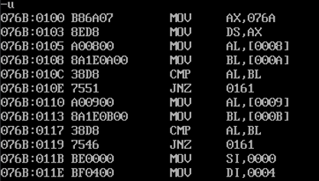

## Snapshot of sample input and output:

**INPUT:**

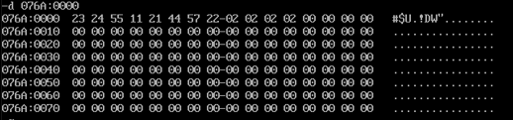

**OUTPUT:**

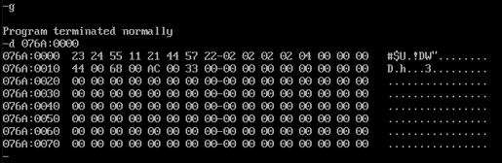

### 

### (ii) Matrix Subtraction

## Algorithm:

* Declare the data segment.
* Initialize data segment with matrices 1 and 2, with their dimensions and resultant matrix.
* Close the data segment.
* Declare the code segment.
* Set a preferred offset (preferably 100)
* Load the data segment content into AX register.
* Transfer the contents of AX register to DS register.
* Compare row1 and row2, if not equal then exit the program
* Compare col1 and col2, if not equal then exit the program
* Position SI at matrix1, and DI at matrix2.
* Multiply row1 and col1 to find length len of the matrix.
* Move the len to CL register.
* Till CL goes to zero:
  + Subtract values at SI and DI and push it into the stack.
  + Increment SI and DI.
  + Decrement CL.
* Move SI to end of resultant matrix.
* Till CL goes to zero:
  + Pop the value from top of the stack and put it at SI.
  + Decrement SI.

|  |  |
| --- | --- |
| **Program** | **Comments** |
| **assume** cs:code, ds:data | Using assume directive to declare data, extra and code segment |
| **data segment** | Using assume directive to declare data, extra and code segment |
| mat1 db 23h,24h,55h,11h |  |
| mat2 db 21h,44h,57h,22h |  |
| row1 db 02h |  |
| col1 db 02h |  |
| row2 db 02h |  |
| col2 db 02h |  |
| len db 00H |  |
| resi dw ? |  |
| **data ends** |  |
|  |  |
| **code segment** | Start the code segment. |
| org 0100h | Initialize an offset address. |
| **start:** mov ax, data | Transfer data from “data” to AX. |
| mov ds, ax | Transfer data from memory location AX to DS. |
|  |  |
| mov al, row1 | Move row1 to AL |
| mov bl, row2 | Move row2 to BL |
| cmp al, bl | Comparing row count of both matrices. |
| jne break | Exiting if not same. |
| mov al, col1 | Move col1 to AL |
| mov bl, col2 | Move col2 to BL |
| cmp al, bl | Comparing col count of both matrices. |
| jne break | Exiting if not same. |
| mov si, offset mat1 | Set SI to point to Matrix 1’s starting index. |
| mov di, offset mat2 | Set DI to point to Matrix 2’s starting index. |
| mov al, row1 | Move row1 to AL |
| mov bl, col1 | Move row2 to BL |
| mul bl | AL has the value of row1 * col1. |
| mov len, al | Move len to AL |
| mov cl, len | Finding no. of elements in the matrix. |
| mov ch, 00h | Clear CH. |
| mov ax, 0000h | Clear AX. |
|  |  |
| **looper:** mov al, [si] | Pushing each element-wise sum into stack |
| mov ah, 00h | AH <- 00H |
| mov bl, [di] |  |
| mov bh, 00h | BH <- 00H |
| sub ax, bx | Subtract the 2 elements from each matrix. |
| push ax |  |
| inc si | Move to next element in matrix 2. |
| inc di | Move to next element in matrix 1. |
| dec cx | Decrement counter by 1. |
| jz prewrk | If addition is over, jump to “prewrk” |
| jmp looper | Repeat addition for all elements. |
|  |  |
|  |  |
| **prewrk:** mov si, offset resi + 0001h | Set the SI to store values in result matrix “resi” properly. |
| mov cl, len | Set counter to length of the matrix. |
| mov ch, 00h | Clear CH. |
| add si, cx | Set SI to point to the last location of the matrix. |
| add si, cx |  |
|  |  |
| **retloop:** pop ax | Popping each element from stack into resultant matrix. |
| mov [si], al | Move AL to [SI] |
| dec si | Decrement SI. |
| mov [si], ah | Move AL to [SI] |
| dec si | Decrement SI |
| dec cx | Decrement counter by 1. |
| jz break | Stop popping if all elements are popped (CX = 0) |
| jmp retloop | Pop the next element and put it in the matrix. |
|  |  |
| **break:** mov ah, 4ch | Moves the hexadecimal value 4c to ah. |
| int 21h | When Software interrupt 21 is called with AH=4C, then current process terminates. (i.e., These two instructions are used for the termination of the process). |
| **code ends** |  |
| **end start** |  |

## 

## Unassembled Code:

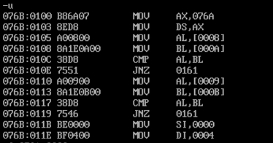

## Snapshot of sample input and output:

**INPUT:**

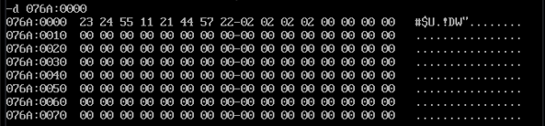

**OUTPUT:**

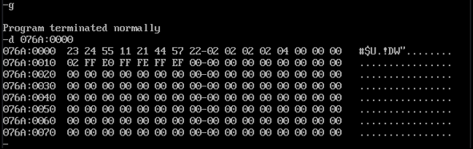

## Result:

The assembly level programs were written to perform the above specified matrix operations and the result was verified.